**Database Project Part 4b**

Github Link:

**Data Manipulation Language Scripts**

1. Add a new column of type ‘ENUM’. Document in your report what the purpose of this column is, and what the choices represent. Add a constraint that prevents null values. Take screen captures of your table before and after the column is created.

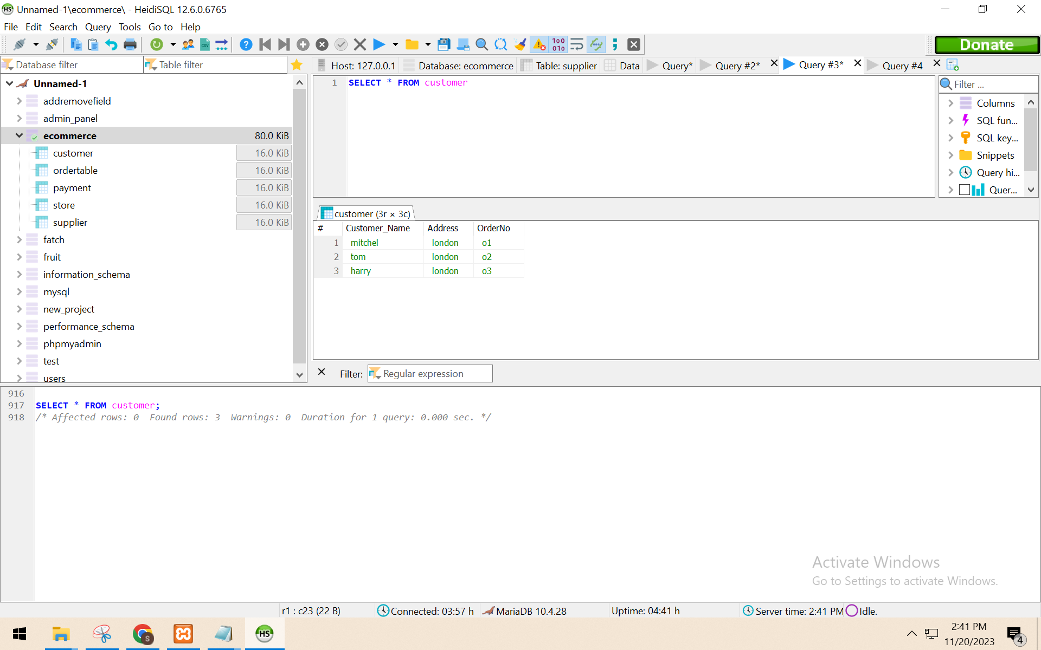

ALTER TABLE customer

ADD COLUMN contact_number ENUM('null', 'home', 'work', 'mobile', 'other') DEFAULT 'null';

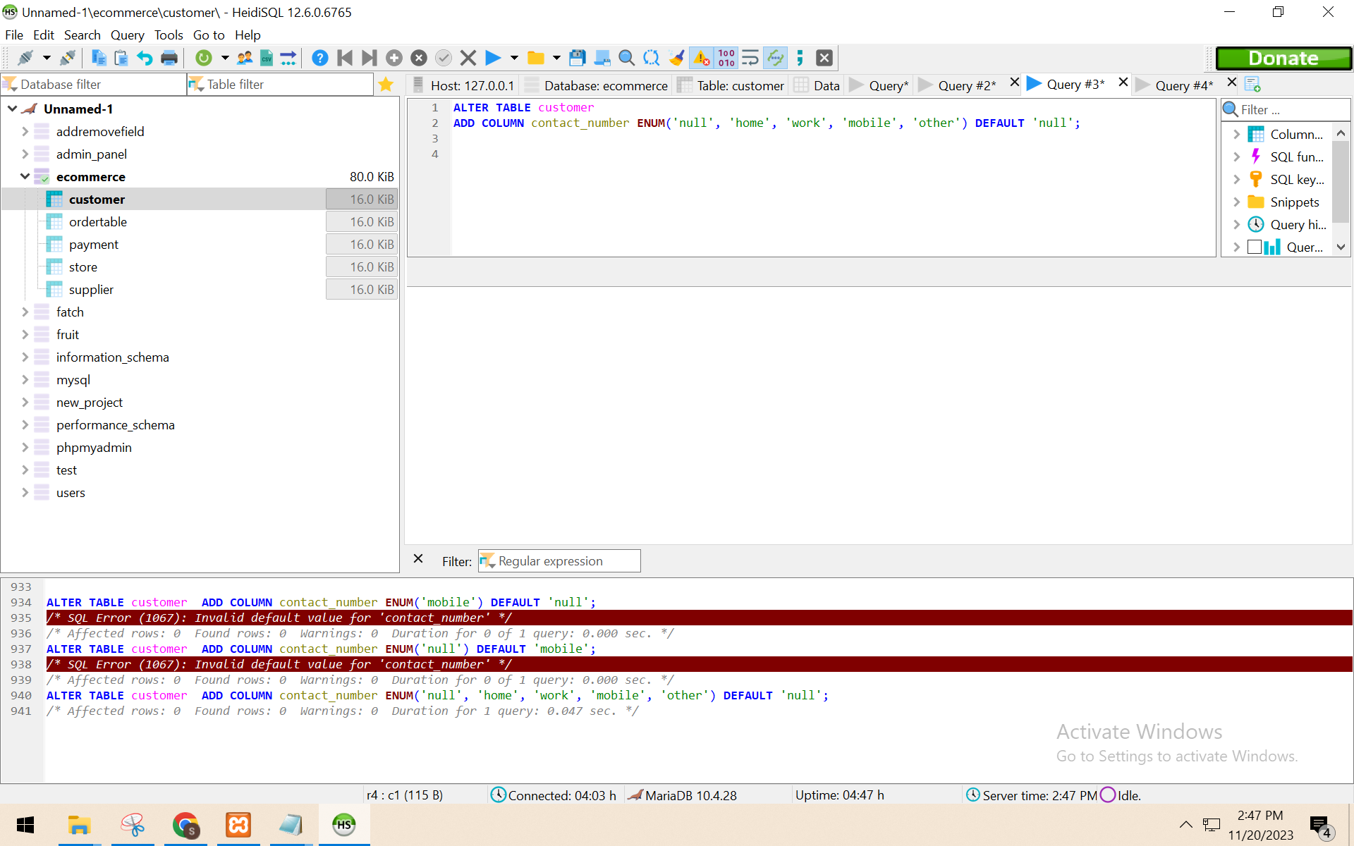

2. Insert a new record of data into the same table that you added the new column. This requires two steps:

a) show that the system throws an error if you try to leave the required ‘enum’ value blank.

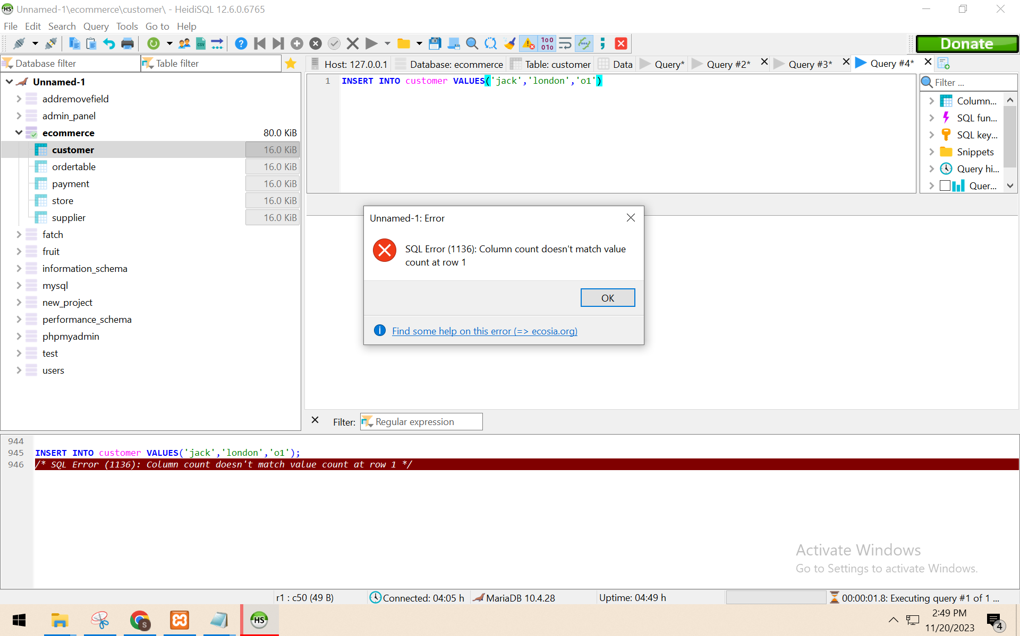

b) modify your insert to include a valid entry so that the data works properly.

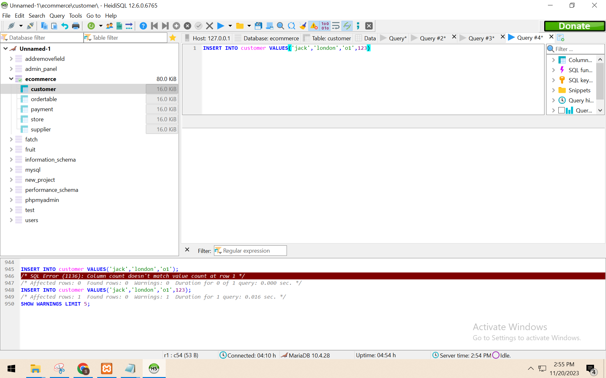

If you can fit all of this in one screen capture, that would be acceptable.

3. In your report, explain what changes you can make to each column of the record you just added in #2. Then, modify that data to show those changes. Include a screen capture that shows the ‘after’ result. The ‘before’ state is already documented from step 2.

First I insert the 3 values instead of 4. That's why i get an error.after i put 4 values the command runs successfully.

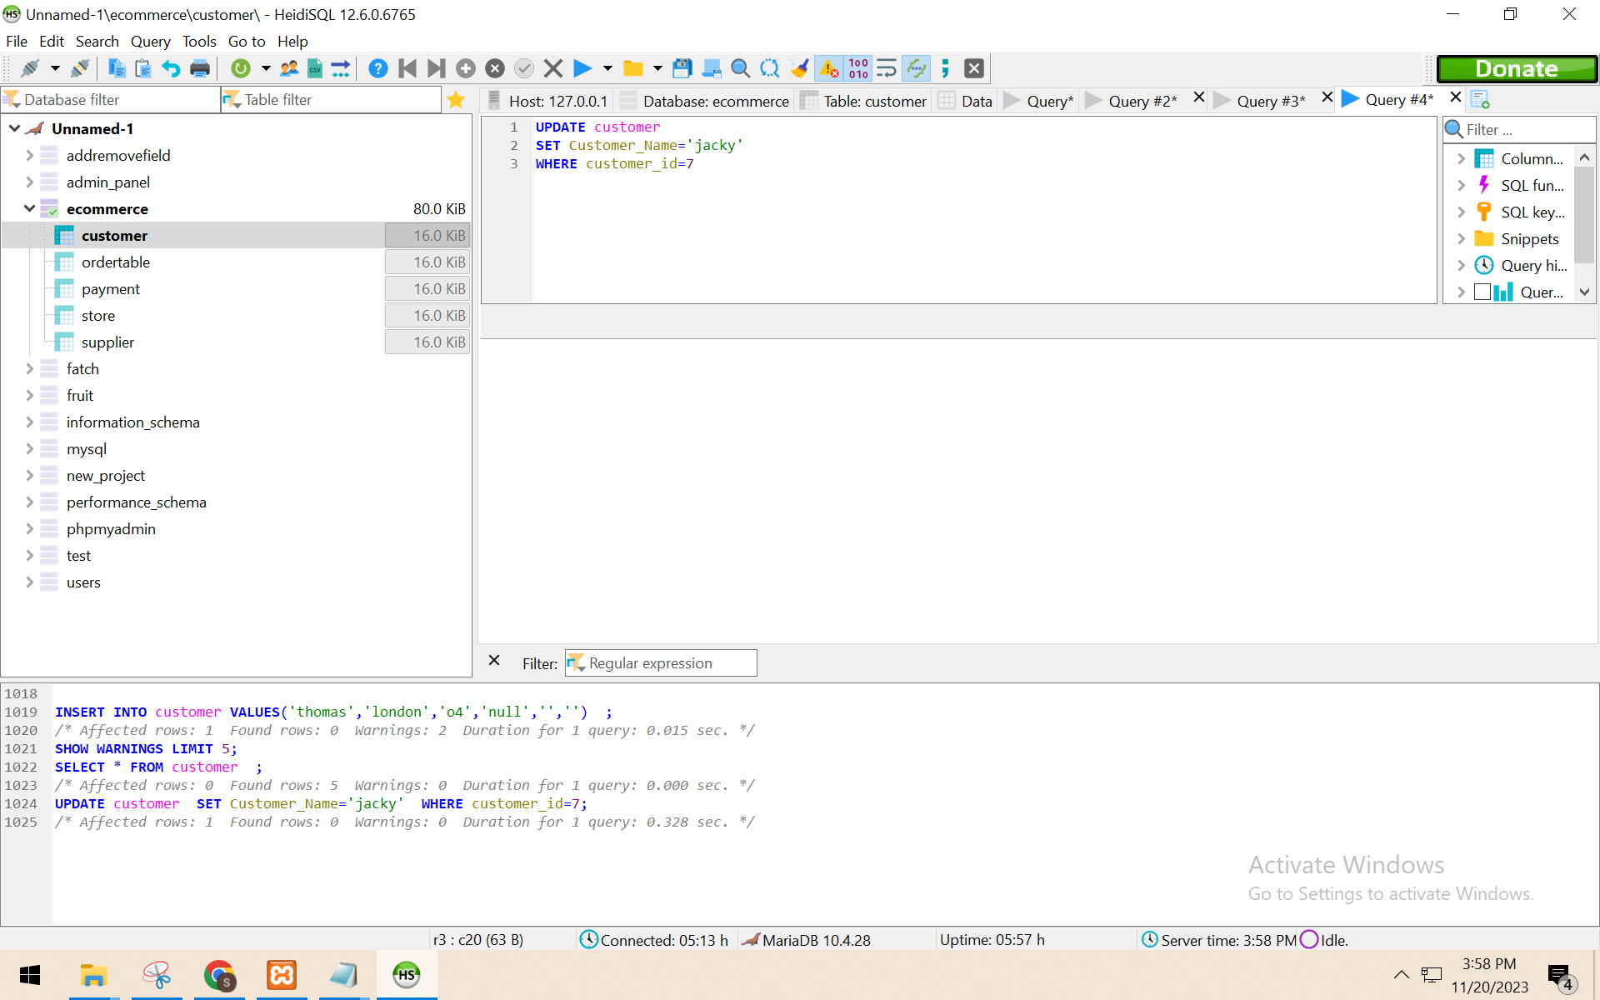

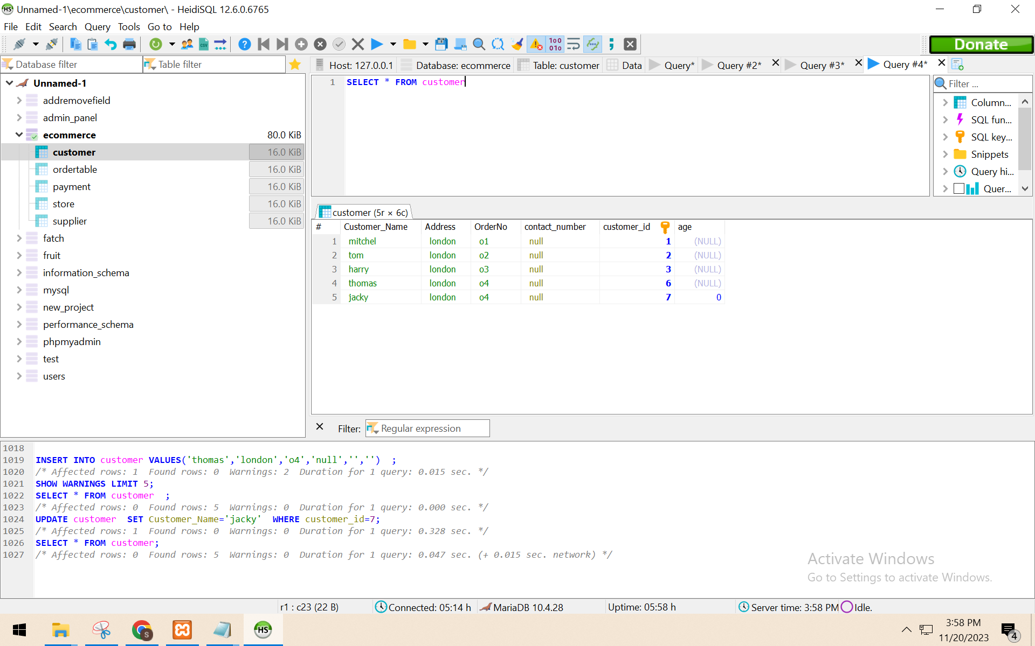

4. Delete the new record. Use the ‘where’ clause to specifically select just the new record. Show a screen capture of the command and the ‘after’ result.

DELETE FROM customer where Customer_Name='jack'  
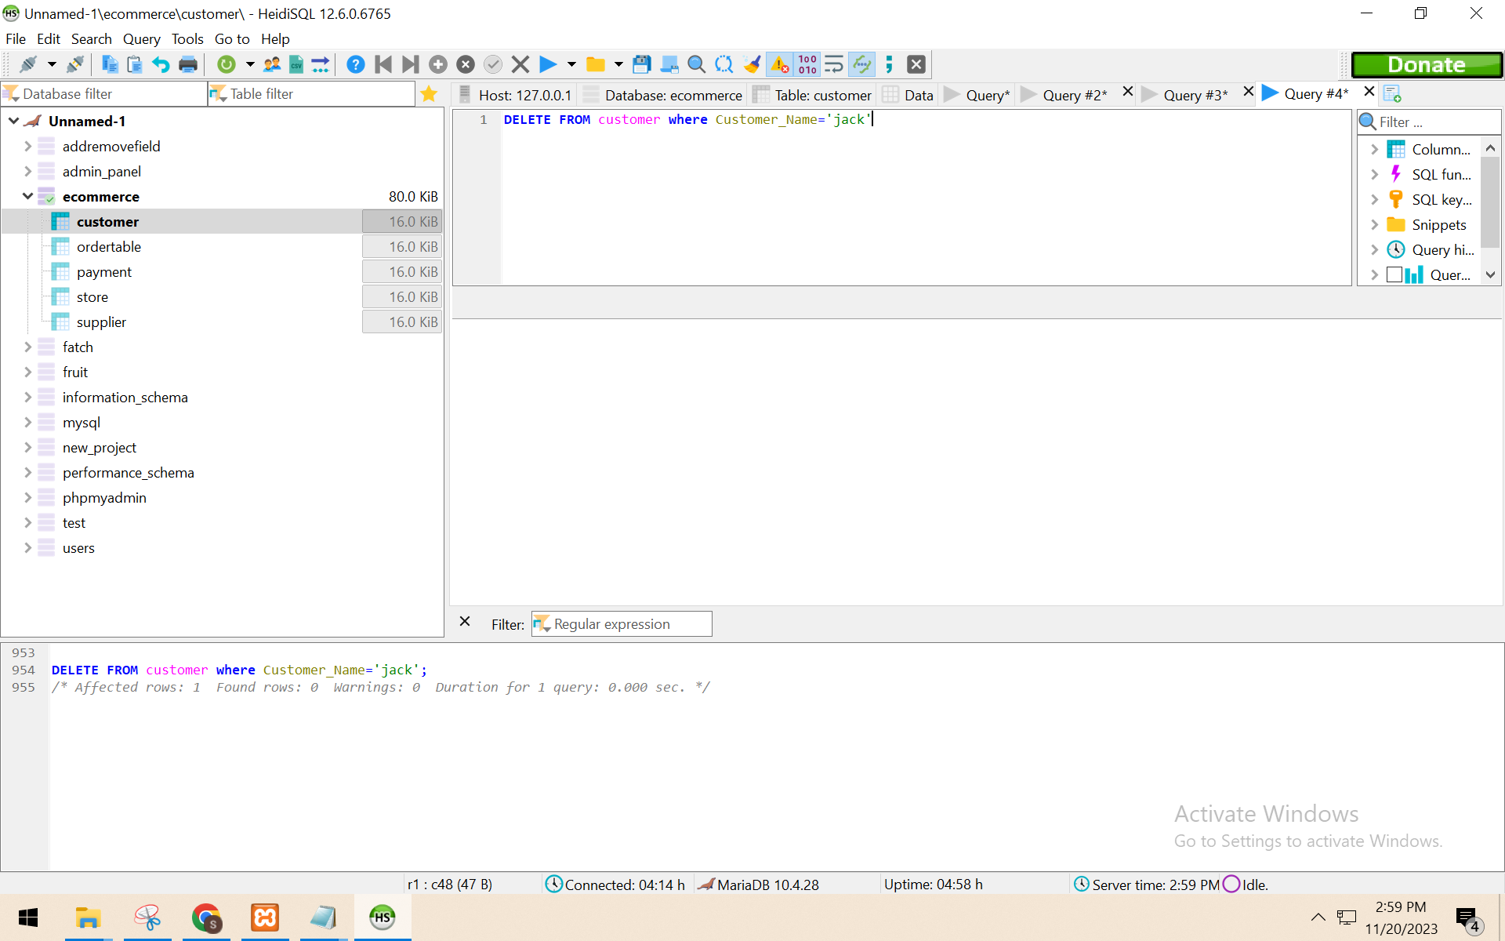

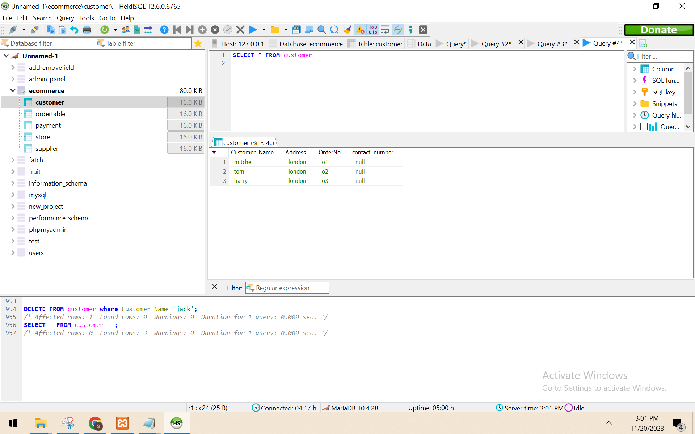  
5. Demonstrate the use of the ‘AUTO_INCREMENT’ constraint by adding a record to a table with this feature. If you do not have this feature already enabled, then alter a table to include a new column. Show a screen capture of the table before you add the new record, and another screen capture after you add the new record to demonstrate the autoincrement.

ALTER TABLE customer

ADD COLUMN customer_id INT AUTO_INCREMENT PRIMARY KEY;

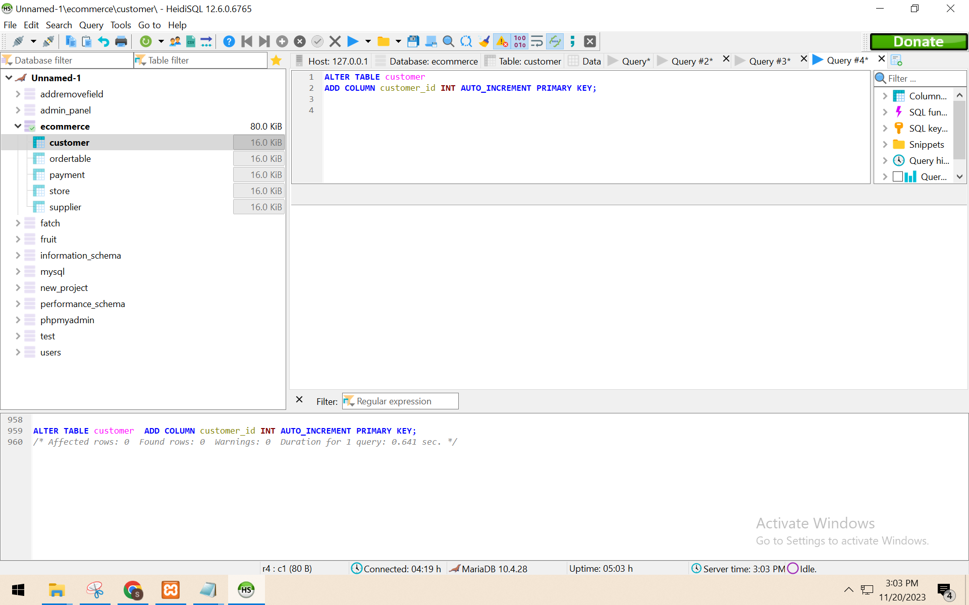

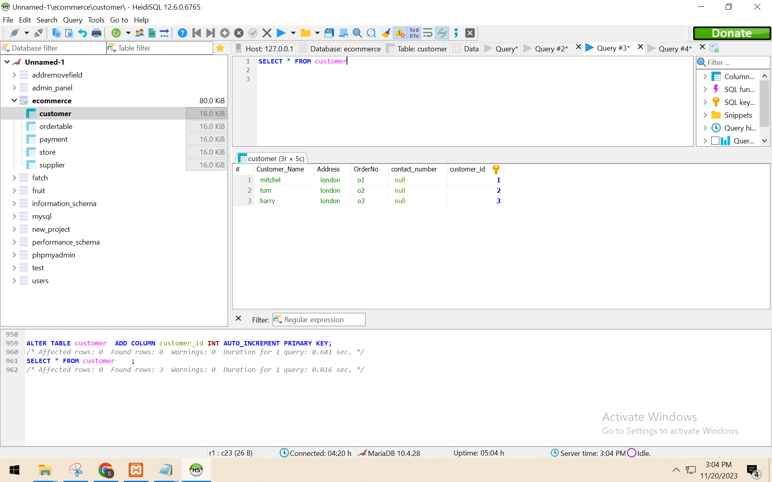

INSERT INTO customer VALUES('thomas','london','o4','null','')

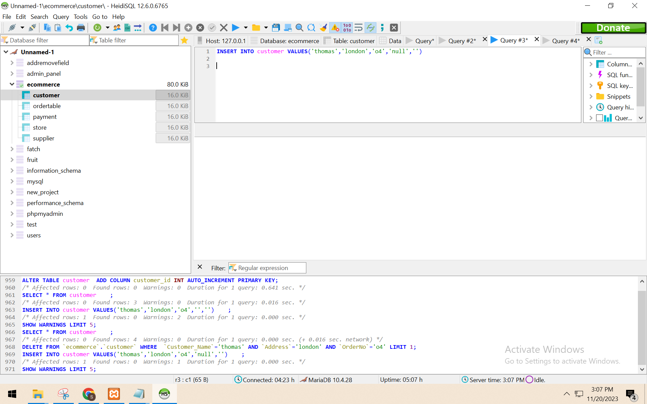

select * from customer

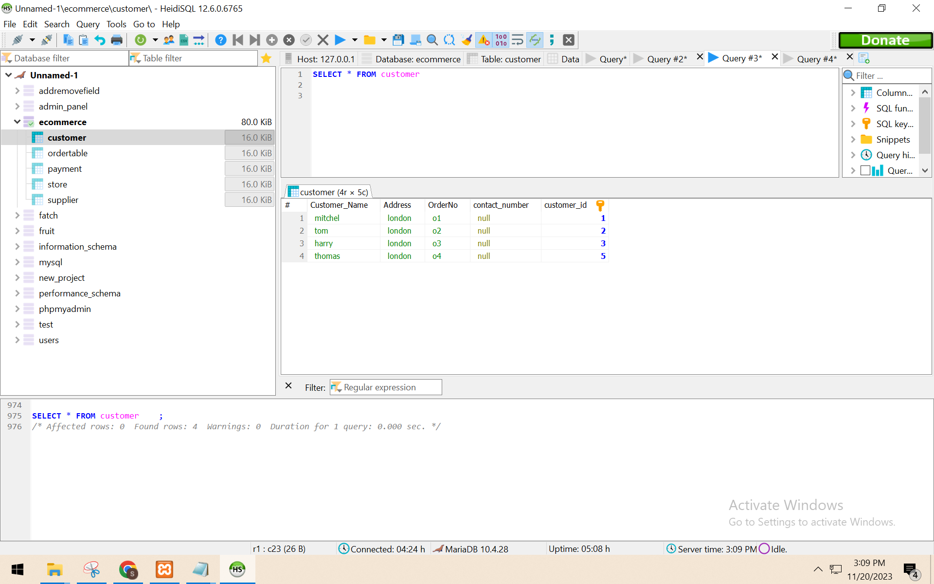

6. Repeat step 5, except demonstrate the use of the ‘DEFAULT’ constraint by adding a record to a table with this feature. You may need to add a column with this feature if you don’t already have it. Prove that adding a new record of data without this value during entry will still get the default value after your ‘insert’ command executes.

ALTER TABLE customer

ADD COLUMN age INT;

ALTER TABLE customer

ALTER COLUMN age SET DEFAULT 0;

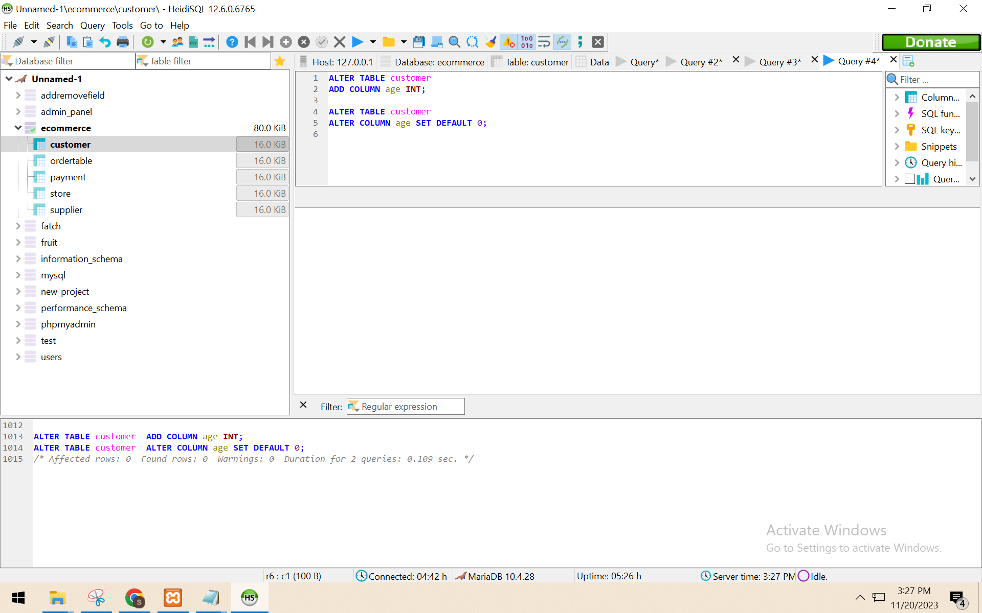

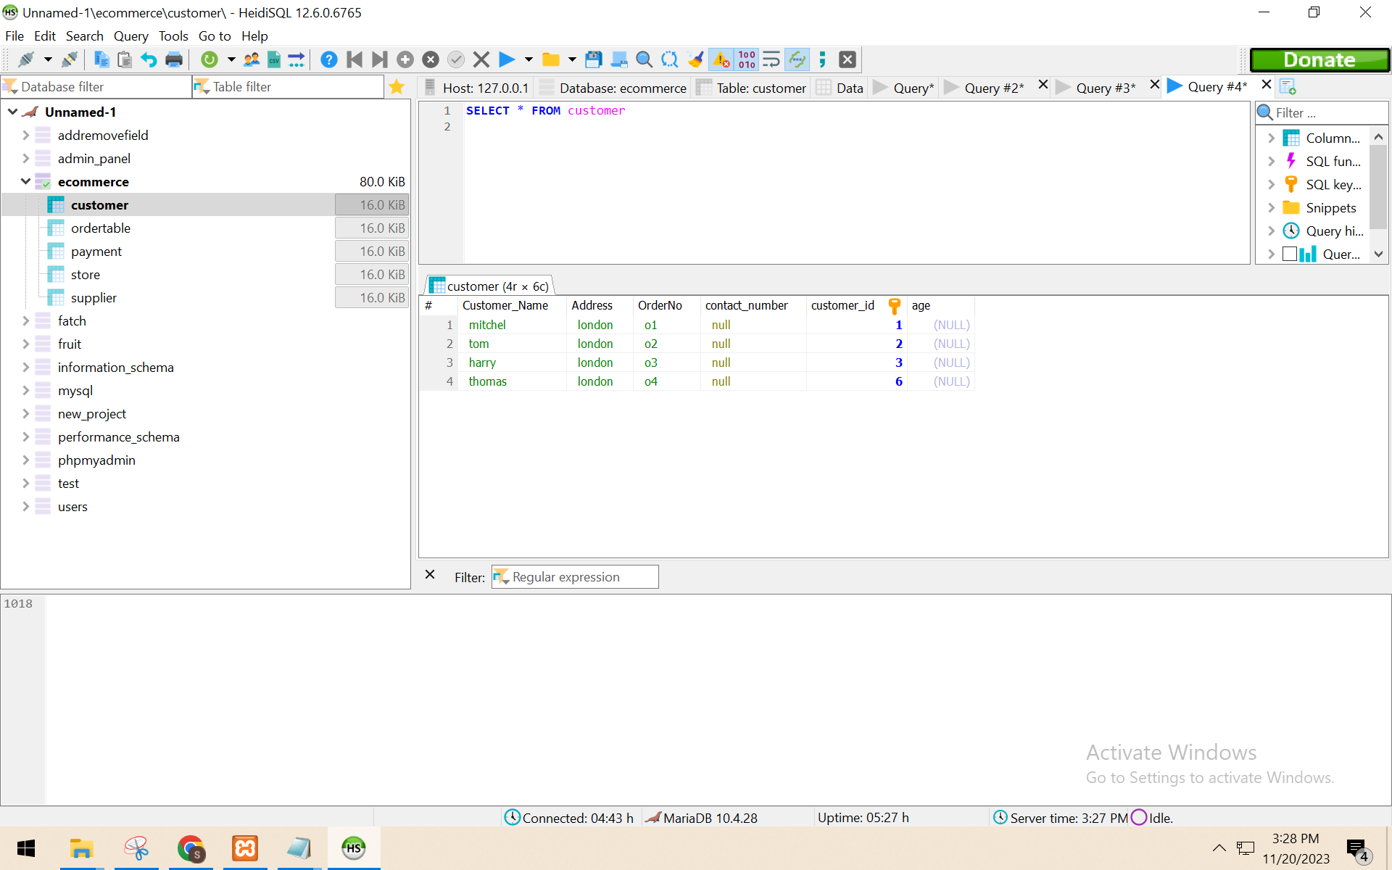

INSERT INTO customer VALUES('thomas','london','o4','null','','')

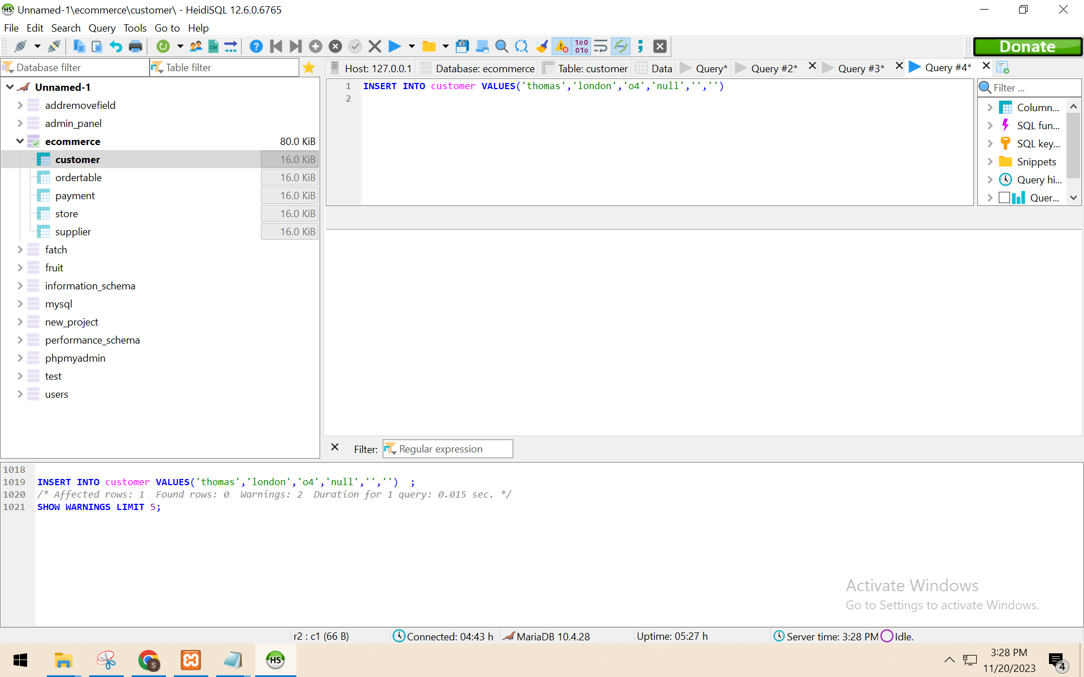

SELECT * FROM customer

